FUNDAMENTALS OF COMPUTING

Name : Y.L.B.SNEHITH

REGISTRATION NO : 192210274

COURSE CODE : CSA5779

SLOT NAME :D

PROGRAM:

**1.NUMBER SERIES 1,2,3,4,5,6,7……..N**

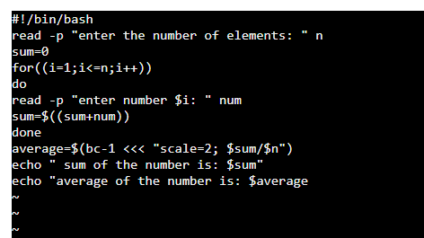

OUTPUT:

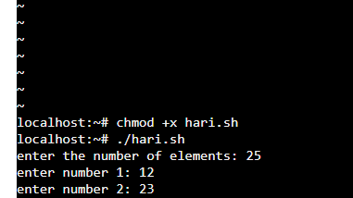

PROGRAM:

**2.FINDING NUMBER WHEATHER EVEN OR ODD**

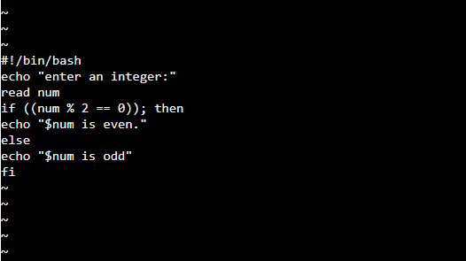

OUTPUT:

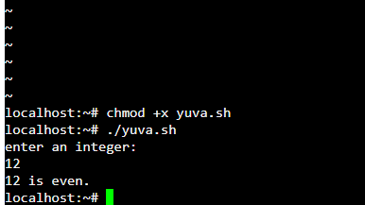

PROGRAM :

**3.FINDING A NUMBER WHEATHER NEGATIVE OR POSITIVE**

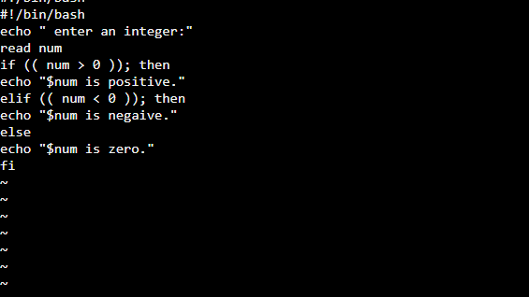

OUTPUT:

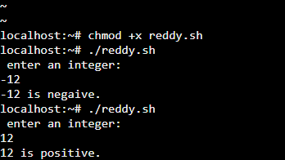

PROGRAM:

**4.SUMMING UP THE ODD NUMBER SERIES :**

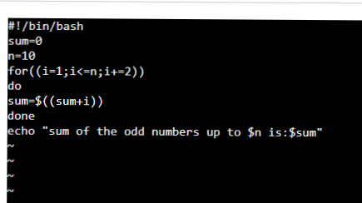

OUTPUT:

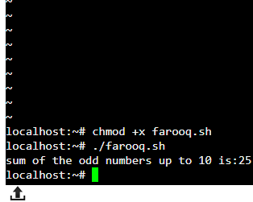

PROGRAM:

**5.SWAPPING OF TWO NUMBERS**

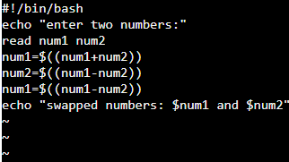

OUTPUT:

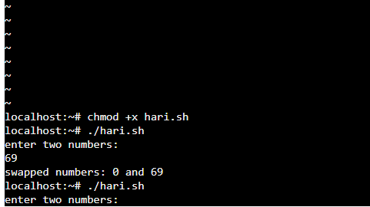

PROGRAM:

6. SUMMING UP EVEN NUMBER SEERIES

INPUT :

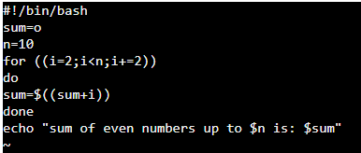

OUTPUT: 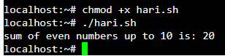

PROGRAM:

7.SWAPPING OF TWO NUMBERS

INPUT:

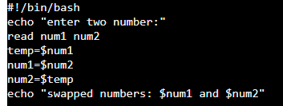

OUTPUT:



PROGRAM :

8.FINDING A NUMBER WHEATHER ARMSTRONG NUMBER OR NOT :

INPUT:

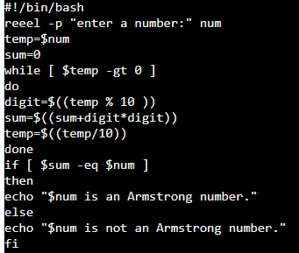

OUTPUT:

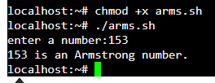

PROGRAM:

9. FINDING BIGGEST NUMBER IN AN INTEGER

INPUT: 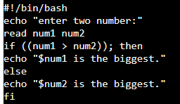

OUTPUT:

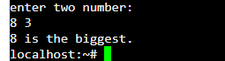

PROGRAM:

10.FINDING LARGEST INTEGER FROM GIVEN INTEGERS

INPUT:

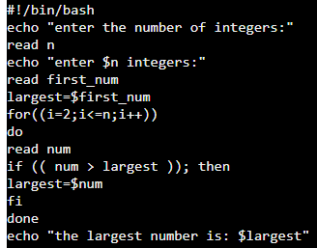

OUTPUT:

